Brian Engel

Module Five Certificate Generation

There are several reasons that you would want to use a certificate authority. They are a trusted third party that creates certificates that verify the website’s authenticity and verifies your identity for the website. This helps reduce the chance of a man-in-the-middle attack, where a bad actor is impersonating the website or resource you are trying to access or impersonating you. In order to get a certificate, you need to create a public and private key for your application and send a request to a certificate authority. They will validate your identity and other information and then send you a signed certificate for you to install in the application. When a user interacts with a site that has a certificate, the browser checks the validity of the certificate, and if it’s valid will establish an encrypted connection using the public key that was created earlier. If the certificate is invalid, the browser will warn you and give you the option to proceed or not.

1. Create the certificate

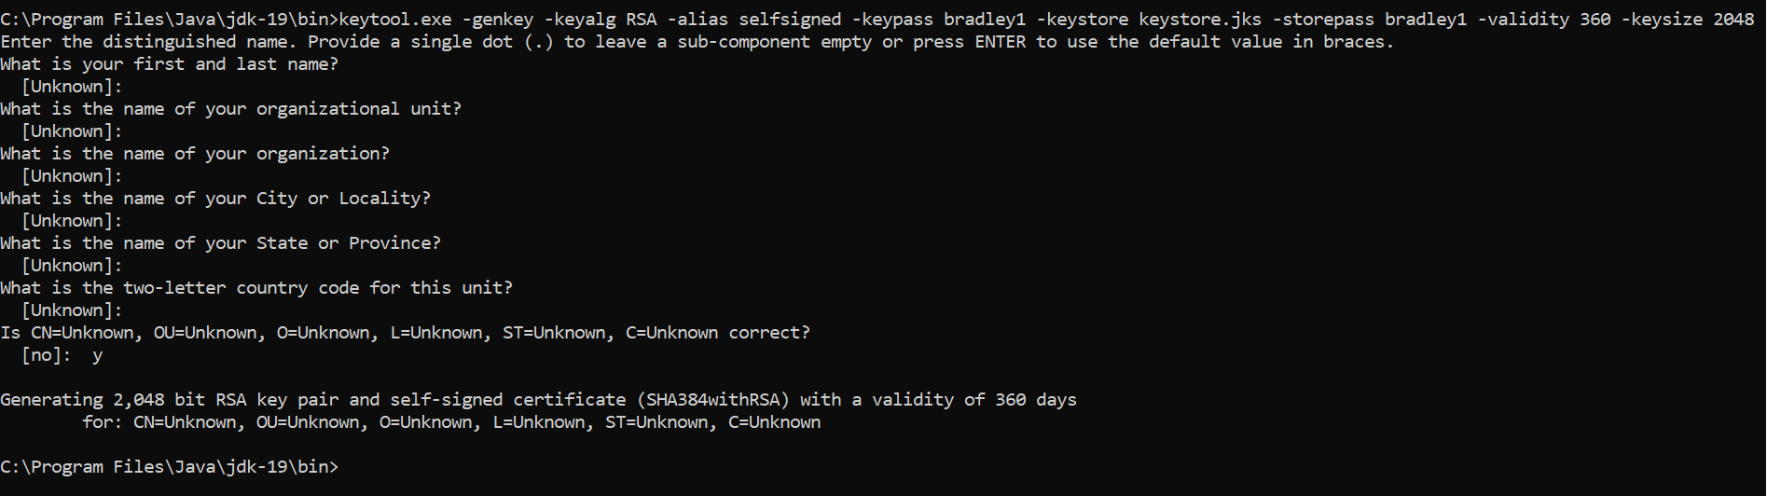

1. Export the certificate



1. Print the certificate

